

The Disney Trip Diary

September 2007

September 9, 2007

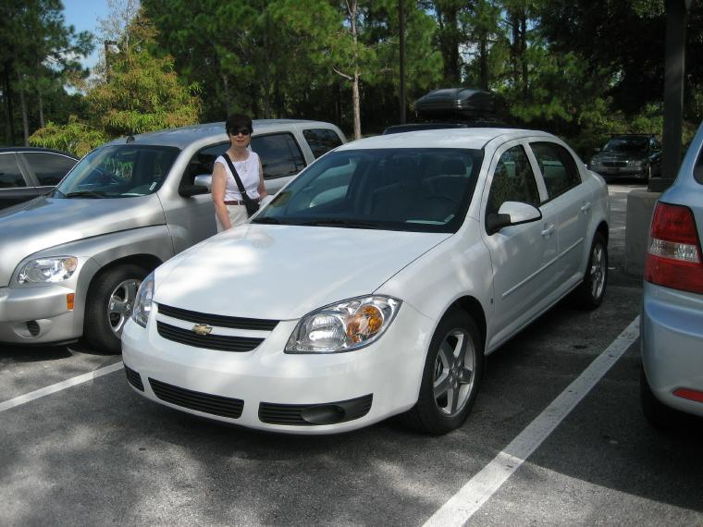
We left Troy Lane at 5:15 AM and arrived at Dulles Airport about 6:35 AM, giving us plenty of time to check our luggage in using the on-line assisted check-in. The United representative had us weigh our big bag to be certain it was not over the 50 pound cut off – it only weighed 39 pounds – at least coming down. Security went smoothly and when we got to our boarding gate, we still had an hour until boarding. So, Doris read and I just watched people. The airport was not crowded, but was busy.

Boarding was easy and the take off and landing in Florida were fine. The plane touched down about 10:45 AM. We picked up our bags and rental car and drove to Disney World without incident. Driving around Disney World is a bit crazy as they don’t identify the roads very well.

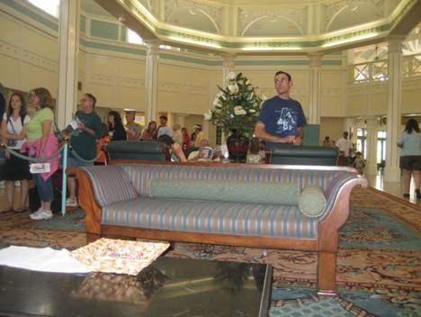
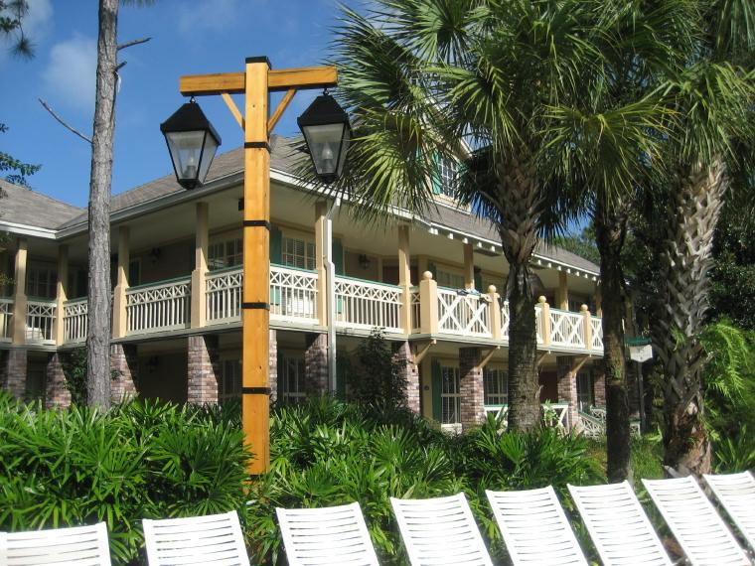
Check-in went great until I asked where our dining pass was and the resort representative said he had no record of our paying for pass. I showed him our on-line receipts and he said he would have his manager handle it. They had to call the Disney Travel Agency to confirm we had paid for the Dining Pass. An hour and a half later, they had it straightened out. We were not happy about the wait, but got through it. We drove to our lodge building and settled in. The room is not fancy but it is small and rustic (joke)! We are close to the pool should we want to cool off some afternoon. Or maybe I will take a dip in the morning!

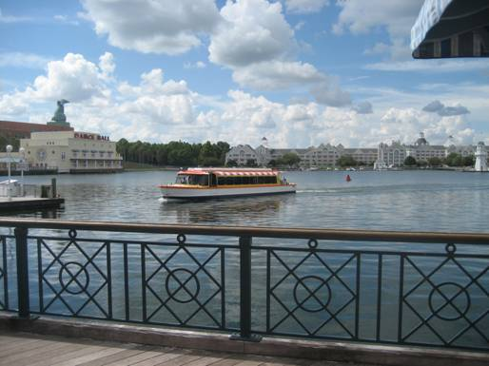
We decided to drive to the Boardwalk Resort to eat at the Big River Grille and Brewery Works for an early dinner since we had not eaten. This is a nice bright resort built around a lake around which a “boardwalk” is built. We had a good meal – Doris had a grilled chicken sandwich with honey-mustard dressing and I had a blackened mahi-mahi filet sandwich. I tried two of their great beers and we brought dessert home. We didn’t have any forks, so we had to improvise eating the chocolate cake and cheesecake.

We got back to the room by about 4:30 PM, just in time for the Men’s Final at the US Open. Since we had been awake since about 4:00 AM, we just relaxed and took it easy the rest of the evening.

Tomorrow? Off we go to Animal Kingdom!

September 10, 2007

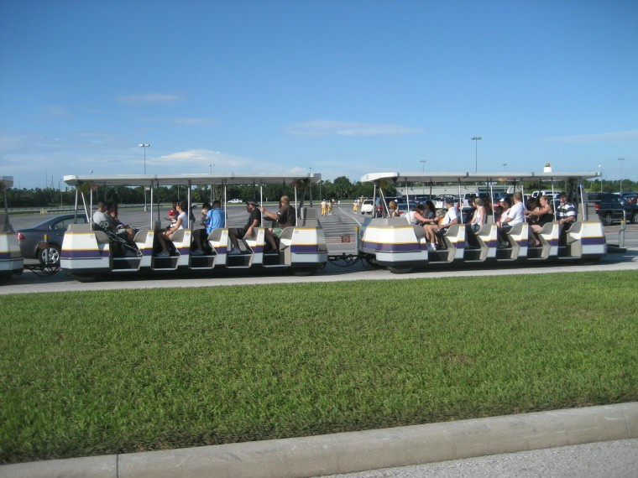
Another beautiful day in Florida this morning! We headed out for Animal Kingdom about 9:00 AM and found it without a problem, even though a major road was closed and we had to do a u-turn and follow a detour. After parking we took the shuttle train from the parking lot to the entrance.

Once inside the park, we headed straight for “Africa” and got in line for the Kilimanjaro Safari. It was a pretty good ride; we saw elephants, giraffes, crocodiles, lions, wart hogs, hippopotamuses, a lot of birds and a number of other range animals. It would have been nice to have had more opportunities for animal photos, though. After this ride, we walked around the area for a while and then decided to get something to eat.

For lunch at this park, we ate at the “Flame Tree Barbeque” restaurant. Doris got a smoked turkey sandwich, cole slaw, and a frozen lemonade. I got a half-rack of barbequed ribs, baked beans, corn muffin, and key lime pie. Great food and all covered by our Dining Plan.

After lunch, we went to a great show – “It’s Tough to be a Bug” – which utilized 3-D effect created by special glasses, and special movements of your seat. Scent, smoke and noises also added a certain reality to the show. It was quite entertaining, but as soon as it started at least 3 – 4 small children started screaming and had to be removed from the theater by their parents.

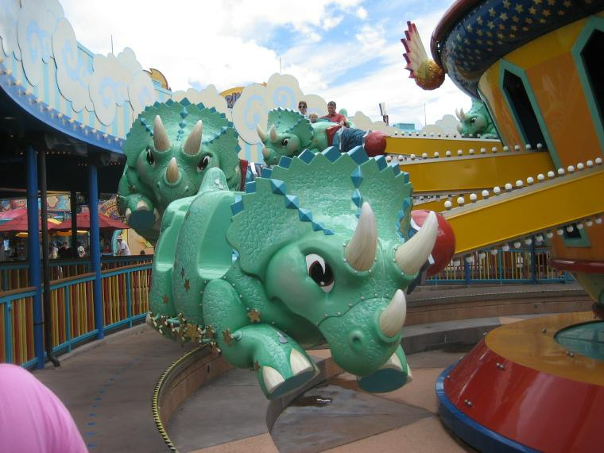
Our next ride was the Triceratop Spin, a minor carnival-type ride. This was followed by another ride called “Dinosaur” about which we knew nothing. It was described as a trip to the past to bring back a dinosaur. It turned out to be an exciting and very active ride on a train through the dark. The cars would turn quickly, jerk up and down, and throw you about. Along the way dinosaurs would jump out to frighten you. We laughed and screamed throughout the ride! Doris loved it. At the end we purchased a photo taken during the ride.

Next came “Finding Nemo – The Musical” which was a combination of puppets, live singers, and video work. It was a 40-minute show that was very entertaining. While we were in the theater, it rained so we lucked out there.

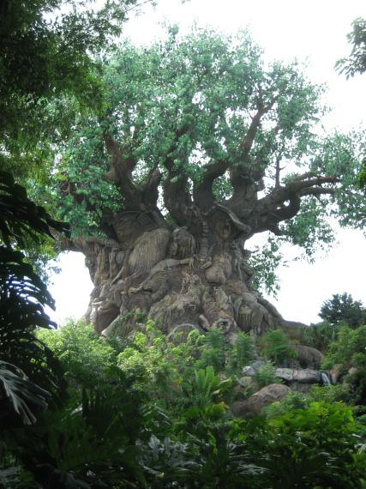
During our day in the park we also visited “Discovery Island” where we saw “The Tree of Life” and we did some shopping.

The final event for us at this park was “Mickey’s Jammin’ Jungle Parade” which came through the park about 4:00 PM. When it was finished we made our way out of the park and back to the car. We drove to the Coronado Resort where we had dinner at the “Maya Grill.”

For dinner we both had a great shrimp cocktail and then went with the Chef’s Special for the day. It was a thick mahi-mahi filet served with couscous and grilled egg plant. The dish was good but not spiced enough for our taste. Doris had a chocolate cake with raspberry sauce and I had a Crème Brule for dessert. They were both very good. While eating, we could watch the chef grilling steaks on a hardwood fire – made me wish I had tried the filet or rib eye steak on the menu! After a short walk, we headed back to our resort and settled in for the night by about 7:00 PM. The area got some heavy rain and thunder storms later in the evening.

Tomorrow we head for the MGM Studio Park. It should be another great day.

September 11, 2007

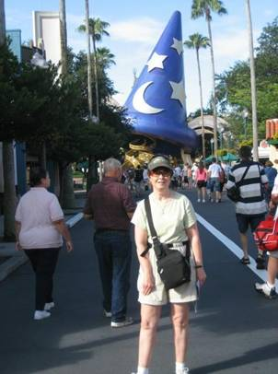
We got an early start this morning, getting to the MGM Studio Parking lot about 9:00 AM. Again, after parking, we took the shuttle to the entrance and found ourselves inside the park in no time at all. We had a long, hot and humid day today, but had a great time and covered quite a few attractions. This is what we did today:

- “The Great Movie Ride” – A ride through a number of animated scenes from great movies of the past.
- “Star Tours” – A Star Wars adventure ride simulating a ride on a space shuttle that gets involved in a shooting war.
- “The Sound Studio” event called “Sounds Dangerous” starring Drew Carey. This show was mostly done in the dark and focused on stereo studio sound effects.

- “Indiana Jones Epic Stunt Spectacular” – An exciting presentation of how special effects are used for making these action movies. It included planes, trucks, fire and explosions.

- “The Disney-MGM Studios Back Lot Tour” – A walking and riding tour through several demonstrations of special effects associated with water.

- “The Magic of Disney Animation” – Demonstration of how animated characters are brought to life on the screen.

- “Playhouse Disney, Live on Stage” – Stanley and the Bear in the Big Blue House are featured in this children’s stage show.

- “Walt Disney: One Man’s Dream” – A nicely done film biography of Walt Disney.
- “Muppets*Vision 3-D” – A hilarious 3-D show featuring most of the Muppets, including the two old men in the box seat.

For lunch we ate at the “Back Lot Express Restaurant.” This quick service eatery had a limited menu and the food was OK. The big benefit was the air-conditioned areas they provided for dining. Doris had a Grilled Turkey and Cheese Sandwich with roasted red sweet peppers and I got chicken breast fingers; both were served with fries. Doris got a Strawberry Parfait for Dessert and I got a small cheese cake.

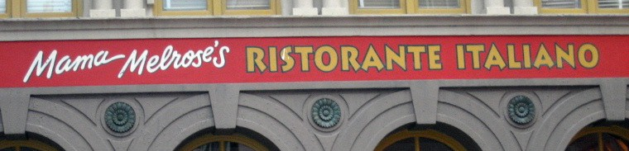
At about 5:40 PM, an hour before our reservations, we went to “Mama Melrose’s Ristorante Italiano” and were seated almost immediately. Service was great here and while the place was busy, our food seemed to be ready in a very reasonable amount of time. For appetizers we got “Crispy Calamari” and “Mozzarella and Tomatoes.” Doris got the “Spa-ghetti Fra Diavolo” with clams, calamari, mussels and shrimp in a spicy marinara sauce. I got the “Wood-Grilled Shrimp” with pipette pasta, artichokes, peas, roasted red peppers in a basil four-cheese cream sauce. For dessert, we both got the “Crema Limone” an un-sweetened lemon custard topped with fresh whipped cream and berries. All of the food was very good, although Doris’ entrée was a bit too spicy for her.

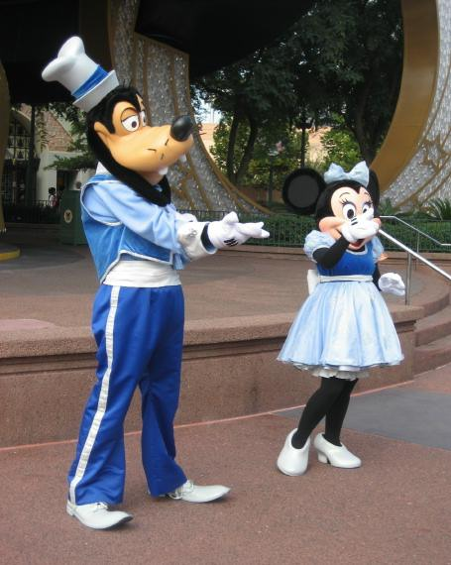
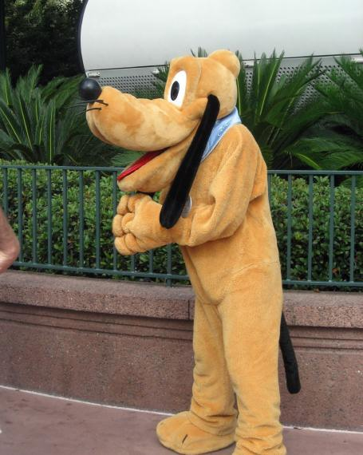
We left the park immediately after eating and returned to our lodge with only a minimal driving mistake due to the detour still in effect. I’ll get it right soon, I’m sure. After we settled in, another storm came through and we got the edge of it, producing a little rain.

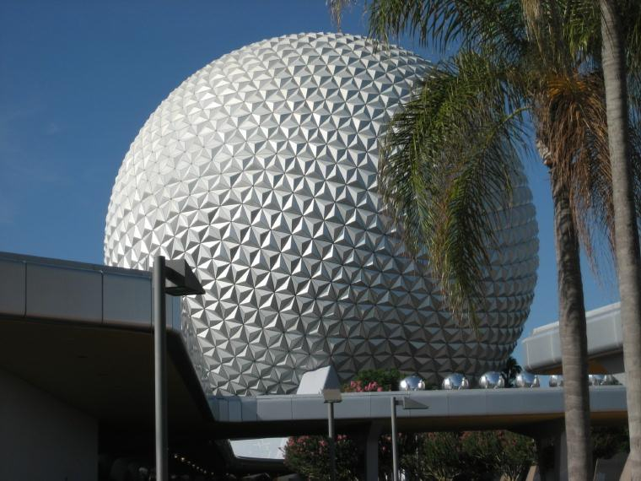
EPCOT is our scheduled park for tomorrow, including dinner there. I am looking forward to this attraction – it has always been my favorite.

September 12, 2007

We took our time getting out this morning, getting to EPCOT about 10:00 AM. We parked and walked to the entrance gates and into the park. It was already in the low 90s and humid.

Our first stop was at the “University of Energy – Ellen’s Energy Adventure”. Ellen DeGeneres is the host of this educational trip back to the dinosaur era.

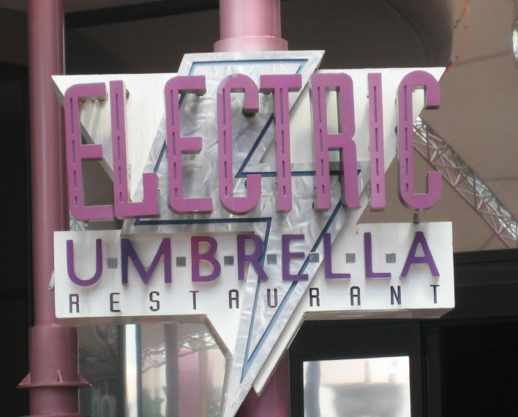
After this attraction we ate lunch at the “Electric Umbrella.” Doris had an “Island Chicken Salad” and I had a “Bacon Double Cheeseburger”.

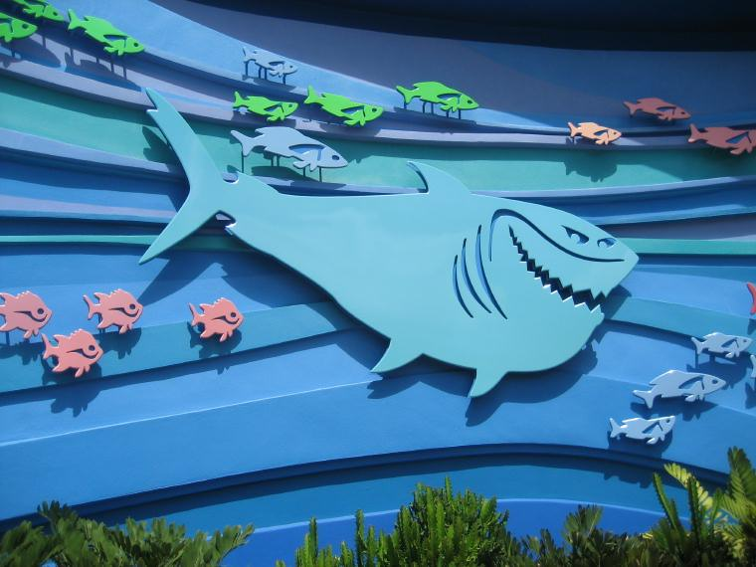
After lunch we went to “The Seas with Nemo & Friends” and the “Journey Into Imagination with Figment.” We also checked out the “Image Works” where we took our own photo and emailed it to ourselves. The rest of the afternoon was spent walking around the “World Showcase” and visiting some of the countries’ attractions. We also did some shopping both before, and after dinner.

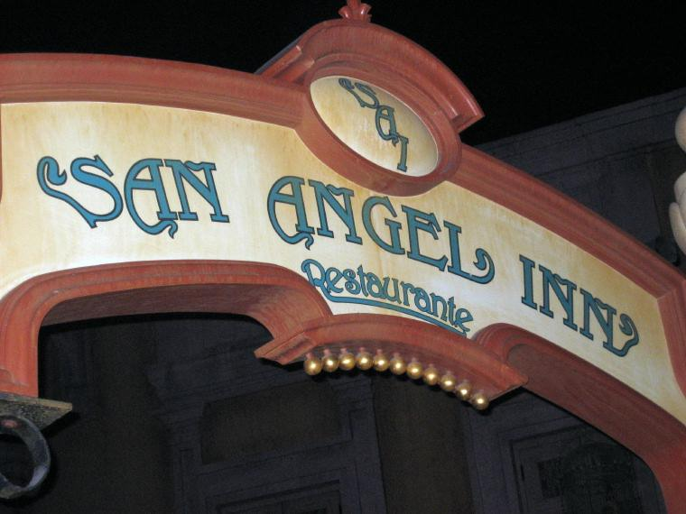
We had dinner reservations in Mexico at the “San Angel Inn” at 5:15 PM. This part of the Mexican display is built on the inside of a huge building but made to look like it was on the outside. It is quite an illusion and well worth the visit.

For dinner we started off with “Frozen Mango Margaritas” and ordered “Nachos” and “Tortilla Soup” for appetizers. While the margaritas sounded good, they were a bit disappointing; they had little taste but were at least cold and refreshing. We both chose the “Filete Motuleno” – grilled beef tenderloin over black beans and melted cheese, sauce ranchero, and fried plantains – for our entrees. We also chose “Flan” for dessert. The entrée and dessert were very good. The beef was very tender and tasty.

We stopped and bought “Vegetable Wraps” for tomorrow’s lunch; one for Doris to eat at the lodge and one for me to take on my guided fishing trip. As happened the previous couple of evenings, a thunder storm rumbled through about the time we finished eating and it started to rain a little. We managed to stay out of most of it as we made our way back to the car and back to the lodge.

I have to be up early tomorrow to head east to the shoreline to meet my fishing guide. Doris decided not to go along because of the intense sunshine we have been having.

September 13, 2007

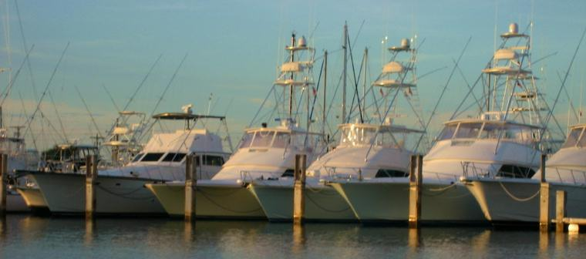
Up at 4:45 AM and off for Cape Canaveral at 5:15 AM – of course, I was awake about every hour during the night, the last time about 4:40 AM so I did not really need the alarm clock! It is an hour’s drive from here to the coast almost all of which is on interstate type roads, one of which has a 70 MPH speed limit. I screwed up a little getting out of the Disney area and ended up doing a turn-around which cost me about 10 minutes. After that I was a bit nervous and stopped twice to check my map to make certain I was on the correct highways. But, encountering no other problems, I pulled into Kelly Park at 6:31 AM, about 5 minutes before Captain Richard showed up with the boat.

Kelly Park is the area Lagooner Fishing Charters uses to launch their boats and is located on the Banana River near Cape Canaveral. Captain Richard is a 45-year old native of the area, a very likeable and good looking man who loves fishing and talking with his clients.

We headed out to the “beach” through “the port” – using terms of Captain Richards. This mean we were headed through the inlet – utilizing “locks” – and into the Atlantic Ocean. The lock was not the kind used to move boats from one water level to another using pumps, it was a means to keep the tidal current from rushing through the inlet causing erosion, silt build-ups, and other damage. It allows only a certain amount of water to move from lagoon to ocean through the inlet at any one time.

It was a spectacular sunrise with a storm and dark clouds hanging low at the ocean’s horizon silhouetted against the orange coloring caused by the morning sun. Photo op? Oh yes. Photos? Nope, my camera was fogged up internally because I stored it next to my cold water bottles on the trip down!
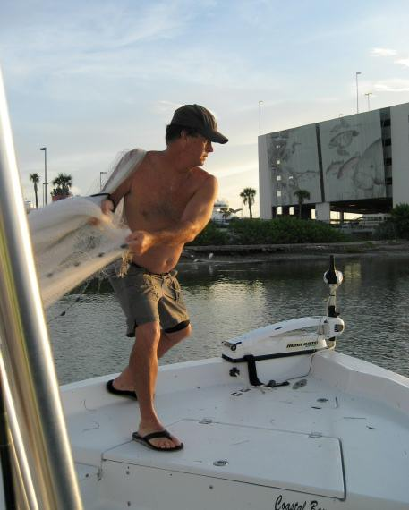
We were away from the dock from about 6:45 AM until about 2:30 PM. After clearing the locks, we searched the port area for mullet to use for bait. Captain Richard used a large casting net to catch about 100 of them for us to use as bait.
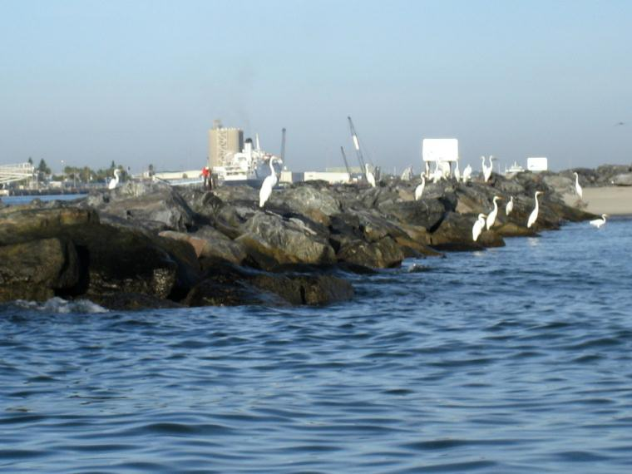
We fished right outside the inlet and jetty, close to shore first. I got a hit there, but we did not catch anything. We fished several other places along the shore line without any luck. The captain then headed north along the shoreline for 20 or 25 minutes and stopped at a spot where there was an old shipwreck near the beach. This was a hot spot and we had hits on our bait fish on every cast. We missed about 75 percent of the hits, it seemed. We caught tailor bluefish and a few jack crevalles. They all were ferocious feeders and very scrappy on the light tackle. One of the reasons we lost so many fish was that the captain used monofilament leaders, not metal. It might have been a little more interesting if we had switched to steel leaders and metal spoons.
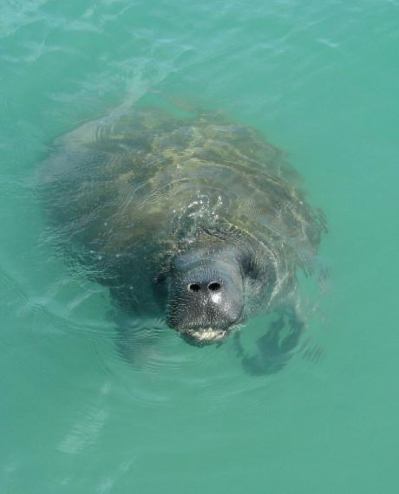
While there a manatee befriended us and kept swimming around the boat, popping her head out of the water now and then and giving us a close look. We saw a number of these huge marine mammals through out the day, as well as a shark or two.

After tiring of feeding the bluefish, we headed out into the deeper water looking for a spot the captain had mapped with his GPS locator. It was a sharp drop-off that fish liked to feed on. He dropped a marker when he found the right spot and then we drifted along the drop-off to or from that spot. We got a good many bites here. The captain caught 3 flounders, two of which were really nice – about 18 – 20 inches long with mouths the size of baseballs. I caught a couple of small black bass but could not pick up the flounder.

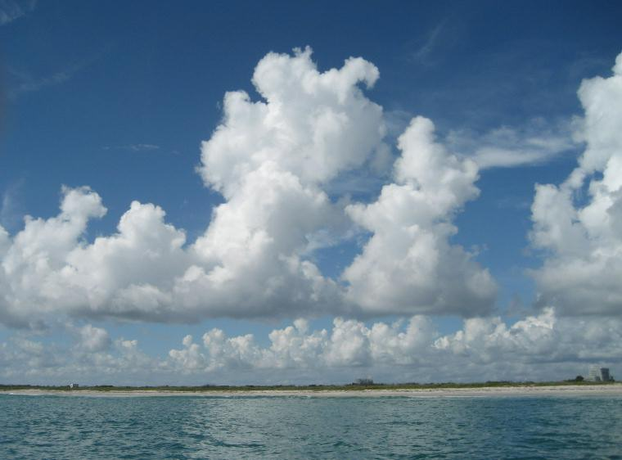
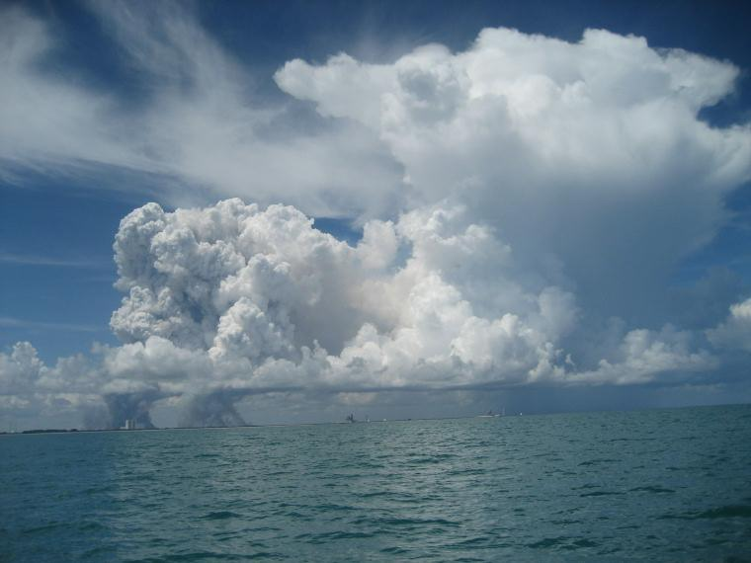
About 1:45 PM we headed back toward the inlet. It was a nice fishing trip, but not a good “catching” trip. The captain was very disappointed, but other captains on the marine radio were also complaining about not finding fish. One of the perks of the day was the great scenery – not only the water and surroundings, but the clouds and the sky were magnificent.

By 2:45 PM I was back in the car and ready to head for Disney World.

For dinner this evening, we ate at the Marrakesh Restaurant in the Morocco section of Epcot. Our reservations were at 5:45 PM but they took us about 45 minutes early. We used the cruise ship to go to and from Morocco which kept our walking in the hot sun to a minimum.

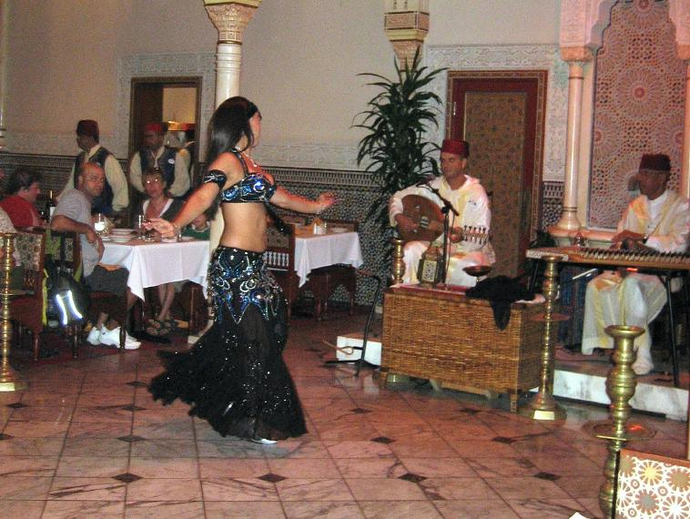
The restaurant was nicely appointed and had live entertainment – a dancer and a two-person “band” that placed Moroccan type music. For appetizers, Doris had the Jasmina Salad and I had the Beef Brewat Rolls, layers of thin pastry stuffed with seasoned minced beef, fried and sprinkled with cinnamon and powdered sugar. We also had Moroccan Iced Mint Tea with our dinner which was wonderful.

For our entrees, Doris had half a Lemon Chicken and I had Roasted Lamb Meshoul. Both were good and large-portioned. For dessert we had a fresh fruit salad topped with mint ice cream, toasted almonds, and orange blossom water. That was very refreshing.

Once again, as we left the park, there was thunder and lightning in the area, but we only got a few drops of rain. I hit the hay early tonight because of the early morning.

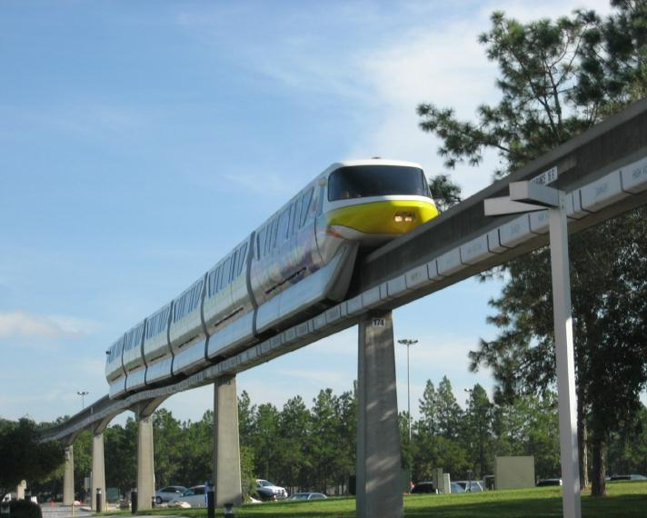
Tomorrow will be a long day. We are headed to “The Magic Kingdom” for part of the day and then will return to our lodge and have dinner here at our resort. Later we will head back to “The Magic Kingdom” for the Halloween Party that goes from 7:00 PM to Midnight.

September 14, 2007

We were up fairly early this morning and out of the lodge by about 9:00 AM. We decided to drive to “Epcot” and take the Monorail from there to “The Magic Kingdom” were we will be spending most of the day. The Monorail made the trip interesting since we had not used it at all this trip. It did add about 30 minutes to the trip but was fun.

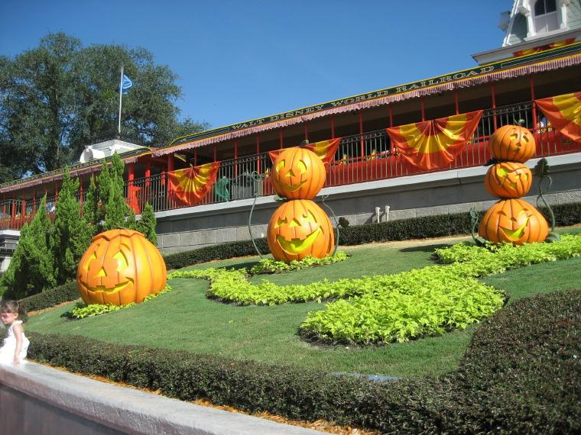
“The Magic Kingdom” was quite busy with a lot of young children. This is really their park. The park was already decorated for Halloween and for that night’s Halloween Party.
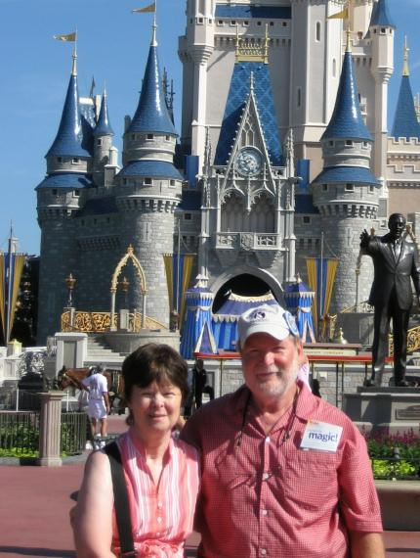
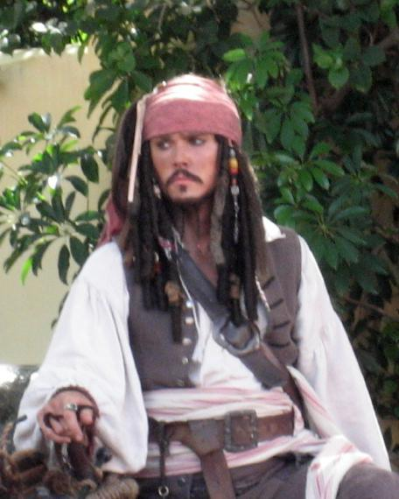
We explored “Main Street” a little and then headed for “Adventureland” where we visited “The Enchanted Tiki Room (Under New Management)” and the “Pirates of the Caribbean” boat ride. We also saw the “Swiss Family Treehouse” and a street show put on by “Captain Jack Sparrow.”

We ate lunch at “Pecos Bill Tall Tale Inn and Café.” Doris had a vegetable burger and I had a pork barbeque sandwich.

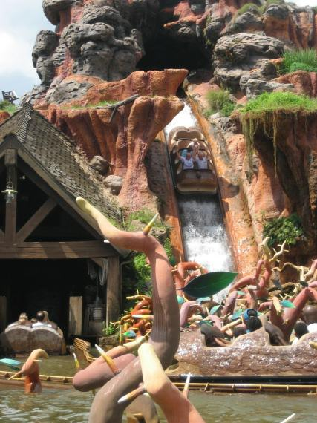
After lunch, we watched the riders shoot down “Splash Mountain” and ride the “Big Thunder Mountain Railroad.” We then walked through the rest of the park, stopping at the “Monsters, Inc. – Laugh Floor,” which was quite entertaining.

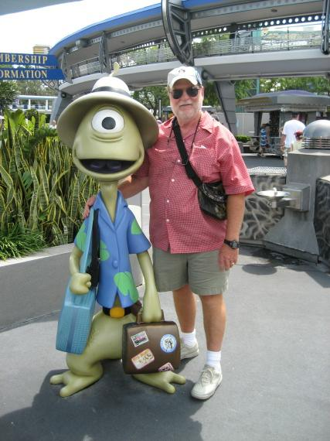
We then retraced the Monorail trip back to Epcot and drove back to the lodge, getting here about 3:00 PM so we could relax a little a rest up before dinner and the Halloween Party.

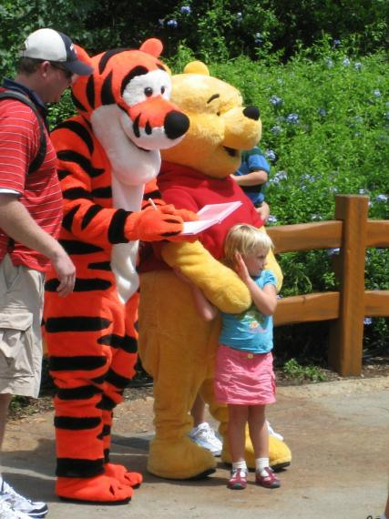
Dinner tonight is here at Port Orleans Riverside at the Boatwright’s Dining Hall. We had reservations for 6:00 PM and were seated promptly when we showed up. For dinner, Doris’ appetizer was a “Seafood Cocktail” – two shrimp and a scallop with a “Thai Chile Lime Sauce”; mine was two “Crawfish Cakes.” She had the “Prime Rib” and I had the “Filet Mignon,” both of these came with “Three-Cheese Hash Brown Potatoes.” For dessert, Doris had “Bananas Foster over “Angel Food Cake and Vanilla Ice Cream,” and I had the “Pecan Pie.”

All of the food was excellent, although the pie was a tad on the dry side for my tastes. The service was great also.

After dinner we headed for “The Magic Kingdom” parking area to go to the Halloween Party and noticed on the way an approaching storm to the west of us. This was just at sundown and was quite breath-taking. After boarding the monorail for the park, it started to rain and then came the thunder and lightning. By the time we got to the park it was 7:30 PM so we decided to wait in the monorail station until the storm passed. Two hours later it finally stopped raining except for an occasional sprinkle and the thunder and lightning has subsided. The fireworks were supposed to start at 9:30 PM so we decided to watch them from outside the park if possible. We finally found out pretty much everything except the trick-or-treating had been cancelled. We got the cost of our tickets refunded at Guest Services and headed back to Port Orleans, stopping to get some drinks for the room.

So, we toddled in about 11:00 PM having spent our last evening doing nothing but watching people! At least we got our money back!

Tomorrow we check out and will probably check out “Downtown Disney” until it is time to go to the airport to catch our 5:00 PM flight home.

September 15, 2007

This morning we packed up everything and left the room. Express check out took care of the need to actually go to the lobby to check out, but we did go there to use the free airline check-in service they offer. They also checked our two bags and took them to the airport for us. While the line was a little long when we got there, it was nice not having to deal with the luggage after getting to the airport.

After taking care of the housekeeping stuff, we had wanted to take the river boat down to “Downtown Disney” but the lake around the destination area was closed to the boats due to a water skiing event going on that day. So we drove to the “Downtown Disney” area and got a parking place fairly close to the shopping areas.
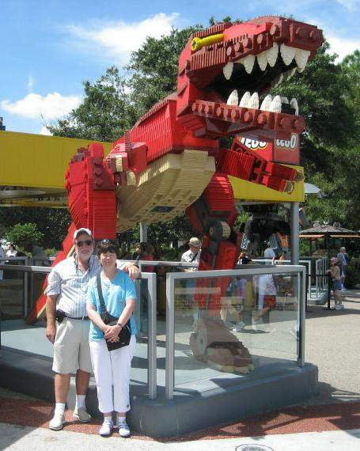
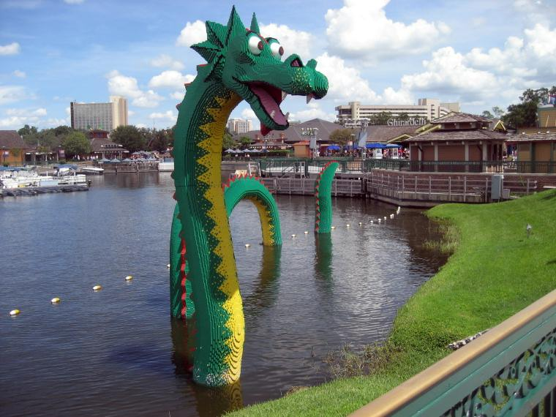
We walked from one end of the area (West Side) to the other (Market Place) stopping in at a number of the shops to look around and cool off. One of our favorites was the “Lego” store and the displays they had out front.

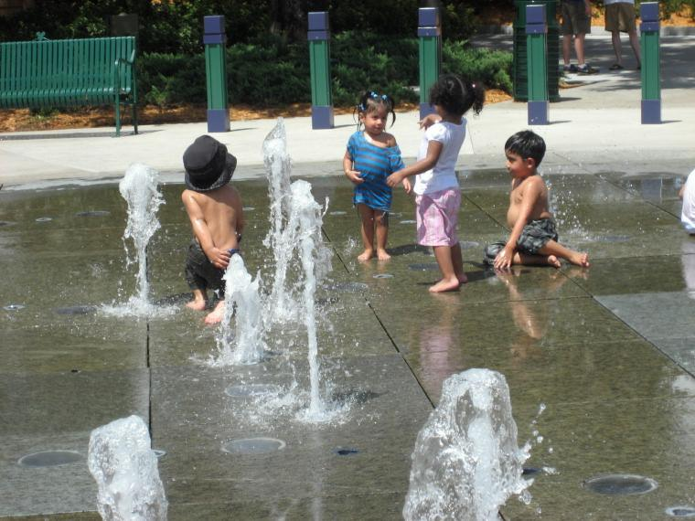
We ate lunch at the “Raglan Road Café” – an English/Irish kind of quick serve restaurant right next to a full service restaurant and bar. Doris had a “Cesar Salad with Chicken” and I had “Battered Mini Sausages and Chips.” I had so much food I could not eat all the sausage and potatoes! For dessert, they gave us “Fried Candy Bars.” Now they were great! They were a Snickers-like candy bar on a stick, battered, and then deep-fried. They were warm and gooey with chocolate, nuts and caramel inside! No healthy stuff there!

We did find an amusing area! In an open area in the Market Place, Disney had placed some small street-level fountains that were meant for the kids to play in. A number of children were there and having a great time. It was all we could do to not join in!

About 1:30 PM we decided we had had about enough of the fun and sun and left the area. We got gas at a local station and headed for the airport. The rental car (Budget) drop-off was great and only took a few seconds. With no luggage except our carry-on bags, the airport experience was painless. Doris and I made our way to the appropriate gate and played cards for about an hour before they announced boarding. Our flight back was smooth – for the most part – and quick. We landed 11 minutes ahead of schedule. Candice picked us up and I drove home. Unfortunately, I took the wrong turn out of the airport and added another 45 – 50 minutes to the trip home.

We had a great time, but it was good to be home.

Doris and Art Guyer, September 16, 2007

